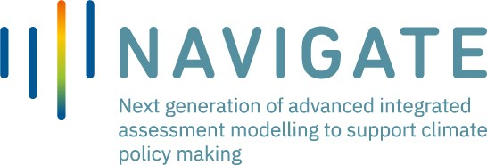

Project funded by European Commission within the H2020 Framework Programme - Grant Agreement N. 821124

NAVIGATE Exchange Programme - Application Form
NAVIGATE project gives the possibility to perform an exchange programme to early and mid-carrier researchers from within or outside the consortium. During the visiting period researchers will have the opportunity to interact with people from different cultural and educational backgrounds.
NAVIGATE offers mobility grants for these abroad visits. Modellers and researchers will share experiences on integrated assessment modelling methods and data analysis, focusing on climate change mitigation, impacts, and adaptation. Moreover, over-arching issues including sustainable development, the implementation of the Paris Agreement, and transformative change will be potential topics for these exchanges.

Terms: Fixed exchange programme period is 90 days.

*Mandatory

- Email address *

……………………………………………………………………….

- First Name (as per passport) *

……………………………………………………………………….

- Last Name (as per passport) *

……………………………………………………………………….

- Date of birth *

……………………………………………………………………….

- Citizenship *

……………………………………………………………………….

- Are you affiliated with an institution that is a member of the NAVIGATE consortium? *

YES NO
- Affiliation *

……………………………………………………………………….

- Position/Job title *

……………………………………………………………………….

- Research fields or area of study *

……………………………………………………………………….

- Country of residence *

……………………………………………………………………….

- Telephone number (including prefix) *

……………………………………………………………………….

- Exchange Programme - Starting on (proposal) - fixed exchange period 90 days *

……………………………………………………………………….

- Together with the application form, the applicant is required to send the following documents: (1) CV; (2) Endorsement of the affiliated institution (recommendation letter from the contact person of your affiliated institution to be addressed to Coordination Board of NAVIGATE); (3) Plan of research activities (200-500 words) which will be carried out during the exchange programme, specifying why they could be interesting for the objectives NAVIGATE project. Please combine the documents into one single pdf file.*

- By sending this form, the undersigned consents to the processing of personal data pursuant art. 13 GDPR 679/16. The information will only be used for the purposes of reporting key participant statistics to the European Commission. The data will be stored securely until the end of the NAVIGATE project (31 August 2023). You may withdraw your consent to the use of the data at any time by emailing the Secretariat Laura Pellizzola, laura.pellizzola@eiee.org *

I Agree

Place, date Signature

